**MINISTRY OF EDUCATION AND TRAINING**



**Capstone Project Document**

**Hotel Website**

**Software Design Description**

**Project Code: HOWE**

**Document Code: HOWE_SDD – v1.0**

Hoalac, June 19th, 2017

Contents

1. PURPOSE　目的 3

2. PROJECT INFORMATION　プロジェクトの情報 3

3. PROJECT MEMBERS プロジェクトメンバー 3

4. OUR PROPOSAL 提案 4

4.1 Problem 問題 4

4.2 Solution 解法 4

4.3 Idea アイディア 4

5. LITERATURE REVIEW OF EXISTING WEBSITES 4

5.1 Kim Lien Hotel キムリエンホテル 5

5.2 Hilton Hotel　ヒルトンホテル 6

5.3 Comparison 6

6. PRODUCT　商品 7

7. BENEFIT FROM PROJECT プロジェクトからベネフィット 8

7.1 For our group グループのために 8

7.2 For user ユーザーのために 8

# Introduction

## Purpose

This document provides a comprehensive architectural overview of the system, using a number of different architectural views to depict different aspects of the system. It is intended to capture and convey the significant architectural decisions which have been made on the system.

## Scope

This Software Architecture Design Document provides an architectural overview of the Hotel Website system, which was developed for Anh Duong Hotel in Tuan Chau Island to promoting hotel’s image, offering customers with a time-saving and efficient booking service, and providing an easy way for hotel in management.

## Definitions, Acronyms, Abbreviations

|  |  |  |
| --- | --- | --- |
| Acronym | **Definition** | **Note** |
| HOWE | Hotel Website | Project’s name |

## References

|  |  |  |
| --- | --- | --- |
| No. | **Document** | **Source/Web Address** |
| 1 | System Requirements Specification Template | FPT University |

## Overview

This document includes:

* Architecture Representation
* Architecture Goals and Constrains
* Use-Case View
* Logical View
* Process View
* Deployment View
* Data View
* Size and Perfomance
* Quality

# Architecture representation

# Architecture Goals and Constrains

# Use-Case View

## Guest View

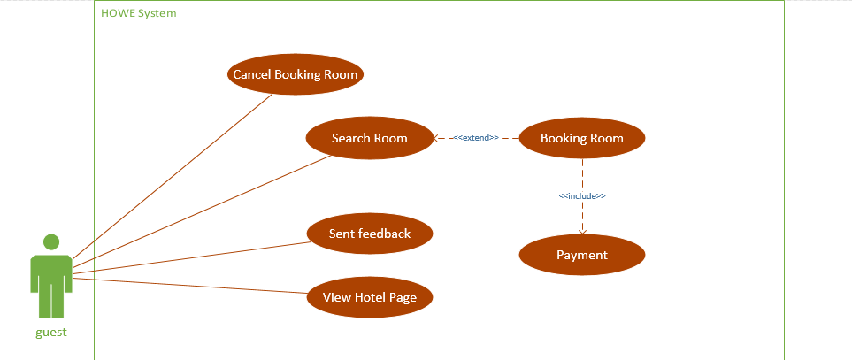

## Receptionist View

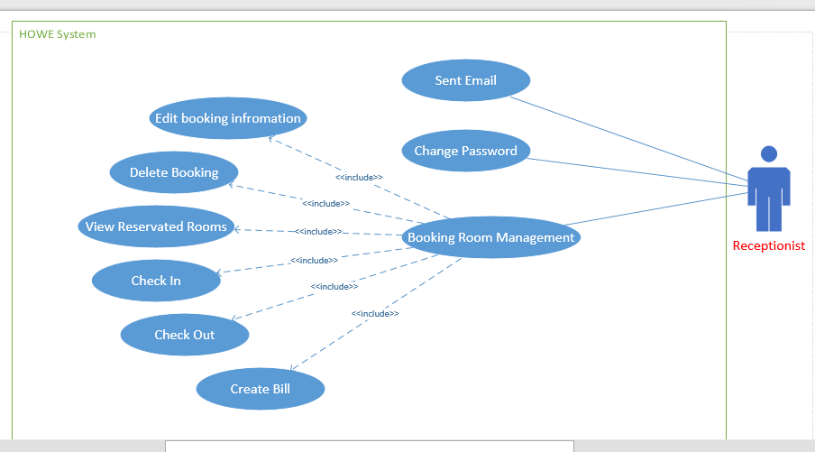

## Manager View

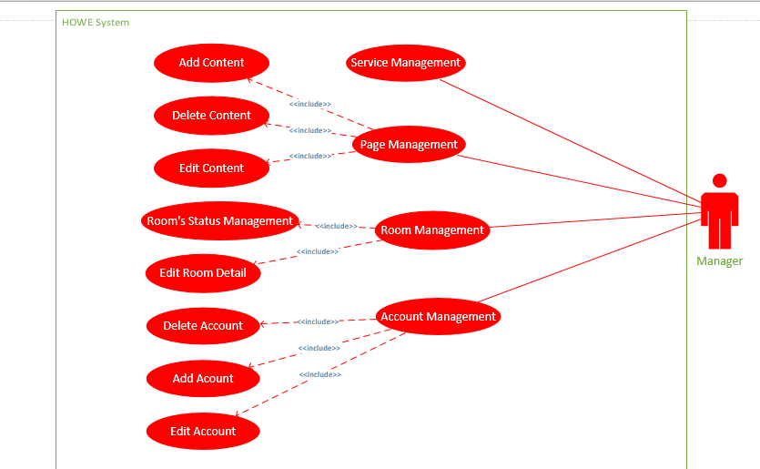

## Accounting View

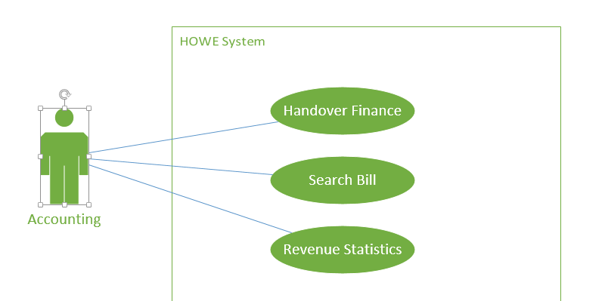

# Logical View

Sử dụng class, sequence diagram

# Development View

Sử dụng component, package diagram 🡪 đánh gia các non-function

# Process View

Activity diagram 🡪 đánh giá các non-function

# Data View

## Database design

## Database detail

### Table tbl_user

|  |  |  |  |  |  |
| --- | --- | --- | --- | --- | --- |
| No | Field Name | Type | Max Length | Allow Null | Description |
|  | user_id | Varchar | 7 | No | Username to login, primary key |
|  | user_name | Varchar | 50 | No | Staff’s full name |
|  | login_pwd | Varchar | 50 | No | Staff’s password |
|  | pwd_regs_ymd | Varchar | 8 |  | Password registers date |
|  | acc_lock_flg | Varchar | 1 |  | 0: enable  1: disable |
| 6 | delete_flg | Varchar | 1 |  | 0: In use  1: deleted |
| 7 | register_ymd | Varchar | 8 | No | Register day |
| 8 | register_cd | Varchar | 7 | No | Register code |
| 9 | register_nm | Varchar | 20 | No | Register name |
| 10 | last_update_ymd | Varchar | 8 |  | Last update date |
| 11 | last_register_cd | Varchar | 7 |  | Last register code |
| 12 | last_register_nm | Varchar | 20 |  | Last register name |

### Table tbl_group

|  |  |  |  |  |  |
| --- | --- | --- | --- | --- | --- |
| No | Field Name | Type | Max Length | Allow Null | Description |
| 1 | group_cd | Varchar | 7 | No | Group staff’s code, primary key |
| 2 | group_name | Varchar | 50 | No | Group staff’s name |
| 3 | register_ymd | Varchar | 8 | No | Registration date |
| 4 | register_cd | Varchar | 7 | No | Registration code |
| 5 | register_nm | Varchar | 20 | No | Registration name |
| 6 | last_update_ymd | Varchar | 8 |  | Last update date |
| 7 | last_register_cd | Varchar | 7 |  | Last register code |
| 8 | last_register_nm | Varchar | 20 |  | Last register name |

### Table tbl_user_group

|  |  |  |  |  |  |
| --- | --- | --- | --- | --- | --- |
| No | Field Name | Type | Max Length | Allow Null | Description |
| 1 | seq_no | Auto incremental |  | No | Primary key |
| 2 | user_id | Varchar | 7 | No | Staff’s code |
| 3 | group_cd | Varchar | 7 | No | Group’s code |
| 4 | register_ymd | Varchar | 8 | No | Registration date |
| 5 | register_cd | Varchar | 7 | No | Registration code |
| 6 | register_nm | Varchar | 20 | No | Registration name |
| 7 | last_update_ymd | Varchar | 8 |  | Last update date |
| 8 | last_register_cd | Varchar | 7 |  | Last register code |
| 9 | last_register_nm | Varchar | 20 |  | Last register name |

### Table tbl_status

|  |  |  |  |  |  |
| --- | --- | --- | --- | --- | --- |
| No | Field Name | Type | Max Length | Allow Null | Description |
| 1 | status_id | Varchar | 10 | No | ID of room status, primary key |
| 2 | status_type | Varchar | 2 |  | Status’s type |
| 3 | status_name | Varchar | 50 |  | Status’s name |
| 4 | description | Varchar | 255 |  |  |

### Table tbl_room_type

|  |  |  |  |  |  |
| --- | --- | --- | --- | --- | --- |
| No | Field Name | Type | Max Length | Allow Null | Description |
| 1 | room_type_id | Varchar | 5 | No | Room type’s ID, primary key |
| 2 | type_name | Varchar | 30 | No | Room type’s name |
| 3 | adult | Integer |  | No | Adult number |
| 4 | children | Integer |  | No | Children number |
| 5 | description | Varchar | 100 |  |  |
| 6 | image_url | Varchar | 100 |  | Image stores address |
| 7 | price | Numeric | 11 | No | With 2 digits after decimal point |

### Table tbl_room

|  |  |  |  |  |  |
| --- | --- | --- | --- | --- | --- |
| No | Field Name | Type | Max Length | Allow Null | Description |
| 1 | room_id | Varchar | 5 | No | Room’s ID and it is primary key |
| 2 | room_type_id | Varchar | 5 | No | Foreign key |
| 3 | floor | Integer |  |  |  |
| 4 | status_id | Varchar | 10 | No | Foreign key |
| 5 | room_number | Varchar | 5 | No | Name of the room |
| 6 | note | Varchar | 255 |  |  |

### Table tbl_room_accessory

|  |  |  |  |  |  |
| --- | --- | --- | --- | --- | --- |
| No | Field Name | Type | Max Length | Allow Null | Description |
| 1 | id | Auto incremental |  | No | Primary key |
| 2 | room_type_id | Varchar | 5 | No | Foreign key |
| 3 | accessory_name | Varchar | 20 | No | Name of accessory in the room |
| 4 | quantity | Integer |  |  | Accessory quantity |
| 5 | price | Numeric | 11 |  | With 2 digits after decimel point |
| 6 | description | Varchar | 100 |  |  |

### Table tbl_guest

|  |  |  |  |  |  |
| --- | --- | --- | --- | --- | --- |
| No | Field Name | Type | Max Length | Allow Null | Description |
| 1 | id | Auto incremental |  | No | Primary key |
| 2 | name | Varchar | 50 | No | Guest’s name |
| 3 | phone | Varchar | 20 |  | Guest’s phone number |
| 4 | mail | Varchar | 50 |  | Guest’s e-mail address |
| 5 | identity_card | Varchar | 12 |  | Guest’s identity number |
| 6 | company | Varchar | 50 |  | Company name |
| 7 | address | Varchar | 100 |  | Guest’s address |
| 8 | company_phone | Varchar | 20 |  | Company’s phone number |
| 9 | country | Varchar | 50 |  | Guest’s nationality |

### Table tbl_reservation

|  |  |  |  |  |  |
| --- | --- | --- | --- | --- | --- |
| No | Field Name | Type | Max Length | Allow Null | Description |
| 1 | id | Auto incremental |  | No | Primary key |
| 2 | status_id | Varchar | 10 | No | Foreign key |
| 3 | guest_id | Integer |  | No | Foreign key |
| 4 | check_in | Varchar | 8 | No | Check in date |
| 5 | check_out | Varchar | 8 | No | Check out date |
| 6 | number_of_room | Integer |  |  | Number of room in the reservation |
| 7 | number_of_adult | Integer |  | No | Number of adult in the reservation |
| 8 | number_of_children | Integer |  | No | Number of children in the reservation |
| 9 | note | Varchar | 200 |  |  |
| 10 | editer | Varchar | 7 |  | Username when staff login |
| 11 | update_ymd | Varchar | 14 |  | Updating reservation date |
| 12 | create_ymd | Varchar | 8 |  | Creating reservation date |

### Table tbl_reservation_detail

|  |  |  |  |  |  |
| --- | --- | --- | --- | --- | --- |
| No | Field Name | Type | Max Length | Allow Null | Description |
| 1 | id | Auto incremental |  | No | Primary key |
| 2 | reservation_id | Integer |  | No | Foreign key |
| 3 | room_id | Varchar | 5 | No | Foreign key |
| 4 | price | Numeric | 11 | No | Reservation’s price |
| 5 | create_ymd | Varchar | 8 |  | Creating reservation date |

### Table tbl_payment_type

|  |  |  |  |  |  |
| --- | --- | --- | --- | --- | --- |
| No | Field Name | Type | Max Length | Allow Null | Description |
| 1 | id | Auto incremental |  | No | Primary key |
| 2 | type_name | Varchar | 50 | No | Payment type name |

### Table tbl_invoice

|  |  |  |  |  |  |
| --- | --- | --- | --- | --- | --- |
| No | Field Name | Type | Max Length | Allow Null | Description |
| 1 | id | Auto incremental |  | No | Primary key |
| 2 | payment_type_id | Integer |  | No | Foreign key |
| 3 | accountant_id | Varchar | 20 | No | Foreign key |
| 4 | receptionist_id | Varchar | 20 | No | Foreign key |
| 5 | guest_id | Integer |  | No | Foreign key |
| 6 | tax_code | Varchar | 10 |  | Tax code number |
| 7 | create_ymd | Varchar | 8 |  | Invoice creating date |
| 8 | amount | Numeric | 11 |  | With 2 digits after decimal point |

### Table tbl_room_invoice

|  |  |  |  |  |  |
| --- | --- | --- | --- | --- | --- |
| No | Field Name | Type | Max Length | Allow Null | Description |
| 1 | room_id | Varchar | 5 | No | Primary key |
| 2 | invoice_id | Integer |  | No | Primary key |
| 3 | create_by | Integer |  | No |  |

### Table tbl_service_bill

|  |  |  |  |  |  |
| --- | --- | --- | --- | --- | --- |
| No | Field Name | Type | Max Length | Allow Null | Description |
| 1 | id | Auto incremental |  | No | Primary key |
| 2 | invoice_id | Integer |  | No | Foreign key |
| 3 | Service_name | Varchar | 50 | No | Name of service |
| 4 | unit | Varchar | 20 | No | Unit of service |
| 5 | quantity | Integer |  |  | Quantity of service |
| 6 | unit_price | Numeric | 11 |  | With 2 digits after decimal point |

### Table tbl_function

|  |  |  |  |  |  |
| --- | --- | --- | --- | --- | --- |
| No | Field Name | Type | Max Length | Allow Null | Description |
| 1 | func_id | Varchar | 7 | No | Primary key |
| 2 | screen_id | Varchar | 7 | No | Primary key |
| 3 | screen_name | Varchar | 50 |  | Name of screen |
| 4 | screen_url | Varchar | 1000 |  | Addressing of the screen |
| 5 | register_ymd | Varchar | 8 |  | Registration date |
| 6 | register_cd | Varchar | 7 |  | Registration code |
| 7 | register_nm | Varchar | 20 |  | Registration name |
| 8 | last_update_ymd | Varchar | 8 |  | Last up date function |
| 9 | last_register_cd | Varchar | 7 |  | Last registration code |
| 10 | last_register_name | Varchar | 20 |  | Last registration name |

### Table tbl_permission

|  |  |  |  |  |  |
| --- | --- | --- | --- | --- | --- |
| No | Field Name | Type | Max Length | Allow Null | Description |
| 1 | role_seq | Auto incremental |  | No | Primary key |
| 2 | group_cd | Varchar | 7 | No | Group’s code |
| 3 | screen_id | Varchar | 7 | No | Screen’s code |
| 4 | use_flg | Varchar | 1 | No |  |
| 5 | register_ymd | Varchar | 8 |  | Registration date |
| 6 | register_cd | Varchar | 7 |  | Registration code |
| 7 | register_nm | Varchar | 20 |  | Registration name |
| 8 | last_update_ymd | Varchar | 8 |  | Last update date |
| 9 | last_register_cd | Varchar | 7 |  | Last register code |
| 10 | last_register_nm | Varchar | 20 |  | Last register name |

# Size and Performance

# Quality

# Others Considerations